**Group Member Names:** Engineering Students at Portland Community College

**Course and Quarter:** Engineering 114 Fall 2019

**Date: November** 18, 2019

**Revision:** Version 1.0

# **Hardware Setup**

**Bill of Materials**

|  |  |  |  |  |
| --- | --- | --- | --- | --- |
| **Part Name** | **Image** | **Purpose** | **Link** | **Price (USD)** |
| Arduino Uno/  R3 Pinout  (DEV-11021) |  | Connecting to the interface shield as well as sending output to computer using MicroUSB | [Arduino Uno R3](https://www.sparkfun.com/products/11021) | **$22.95** |
| Vernier Interface Shield  (DEV-12858) |  | Connecting to the measurement devices as well as sending output to Uno via analog pins | [Interface Shield](https://www.sparkfun.com/products/12858) | **$24.95** |
| pH Sensor  (SEN-12872) |  | Used to measure pH of different water samples and output data to .ino file | [pH Sensor](https://www.sparkfun.com/products/12872) | **$78.95** |
| Turbidity Sensor  (B075H91PY1) |  | Used to measure turbidity of water samples and output data to .ino file | [Turbidity Sensor](https://www.amazon.com/Turbidity-Sensor-Suspended-Particles-Detection/dp/B075H91PY1/ref=asc_df_B075H91PY1/?tag=hyprod-20&linkCode=df0&hvadid=317609719188&hvpos=1o5&hvnetw=g&hvrand=14986883350030508695&hvpone=&hvptwo=&hvqmt=&hvdev=c&hvdvcmdl=&hvlocint=&hvlocphy=9032826&hvtargid=pla-636687453107&psc=1) | **$9.16** |
| Temperature Probe  (SEN-12871) |  | Used to measure temperature of different water samples and output data to .ino file | [Temperature Sensor](https://www.sparkfun.com/products/12871) | **$28.95** |
| Photon Header- 12 Pin Female  (PRT-14321) |  | Used to connect the analog pin inputs on the vernier interface shield in order to plug in more devices | [Photon Header](https://www.sparkfun.com/products/14321) | **$0.50** |

***\*All images taken from*** [***Sparkfun.com***](http://www.sparkfun.com) ***and*** [***Amazon.com***](http://www.amazon.com)

## **Hardware Schematic / Setup**

**Connect the Arduino Uno R3 to the Vernier Interface Shield.** 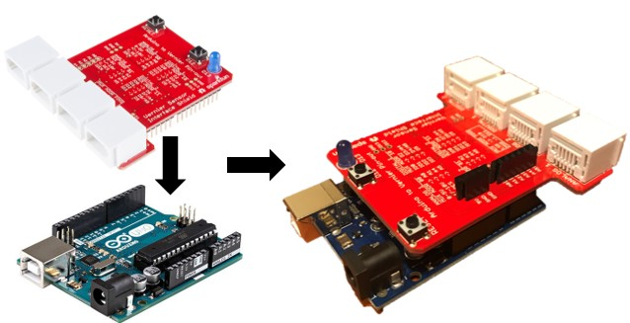

**Solder on some headers to allow connection for a third analog sensor.**

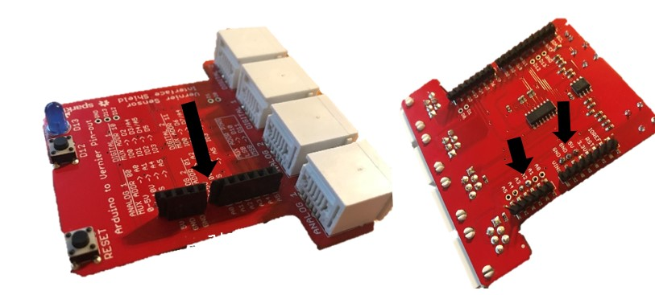

**Connect the sensors to Vernier Interface Shield and the third sensor to the headers.**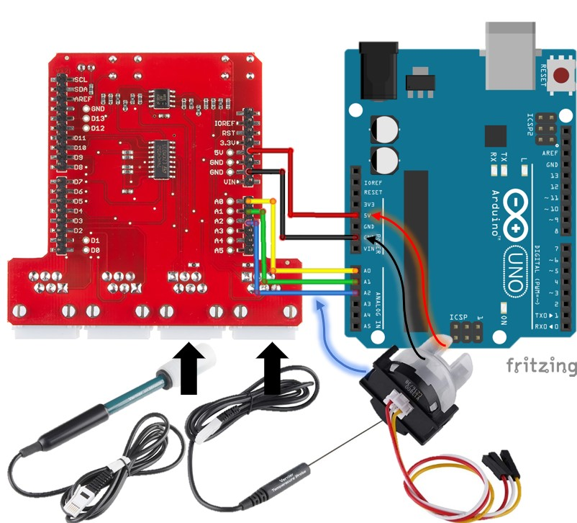

# 

# **Hookup Guide**

For our hardware hookup, we first start with the Arduino Uno R3 (DEV-11021) and plug it into the Vernier Interface Shield (DEV-12858) that gives it the capability to communicate with the vernier sensors and output the data to the ino files using the Arduino Uno R3. We can then plug in the individual sensors. We first start with the pH sensor (SEN-12872) which plugs into the A0 input of the interface shield. The interface shield allows us to use the 5V input, GND as well as the A0 pin for the sensor reading output. We can then plug in the Turbidity sensor (B075H91PY1) into A1 of the interface shield. The setup is the same as the pH sensor but instead of A0 for the output, we use A1. The Vernier Interface Shield only has 2 plug-in ports for analog devices, but has 5 pins on the board itself which means we can use up to 5 devices at once.

In order to use the pins on the board, we must solder some headers (PRT-14321) onto the Vernier interface shield in order to plug in the third sensor which is the Temperature Sensor (SEN-12871). Once all three sensors are plugged in, we can use the MicroUSB cable to connect the UnoR3/Interface block to the computer. We can then use the Arduino Ino files as well as a Python Script in a jupyter notebook to plot out the readings from the three sensors.